Summer Homework • Cartooning 2026
Instructors: Mr. Lassen; Mr. Roonan Mr. Scaglione

RISING SOPHOMORES

Observational drawing
Drawings should be done on drawing paper – 8.5x11 or 9x12
Black and white media: Graphite, pastels, conté crayon.
NOT DIGITAL

Be prepared to submit your work the first week of school.
1. Figure drawing - use these websites for figure drawing - bodiesinmotion.photo, line-of-action.com - or better yet,
have someone pose for you in person!
Draw at least 20 different figure drawings using (2 minutes each) using the simple shapes to draw through
2. Assemble 3-5 items with different heights, textures and forms. Apply a direct light source. Draw and render the still
life items and the table it is upon. Apply the full range of tones to your drawings. Smoothly transition from one tone to
another using traditional pencil rendering.
3. Draw a self-portrait from the shoulders up, focusing on the face. Render your portrait in a cartoon style of your
choice. This can be your personal cartooning style, or a style from your favorite cartoon media.

See this slideshow for guidance - https://docs.google.com/presentation/d/1IdyC4dbhaKIwNqTPBXulGI0fb-yWjh5aUTtIxdZRQww/edit?usp=sharing

Summer Homework • Cartooning 2026
Instructors: Mr. Lassen; Mr. Roonan; Mr. Scaglione

RISING JUNIORS
Cast of Characters Line-Up:
Review the list of character archetypes below. Draw a character lineup using 8-10individual original characters
based on the archetypes from the list. Think of how you can use the principles of stretch and squash to vary their
height, shapes and poses. The original characters should be in a similar style throughout. Use your reference online
or your own reference to pose your figures as needed.
The project can be completed traditionally or digitally.
Look at the examples at the end.

Requirements:
- Pose each character using balance, weight and a dynamic line of action based on their role and personality in your story.
- The line-up should be rendered in either black and white ink or finished in full color.
- They should all be standing on the same plane (as if it was a police lineup)
- The characters should fit onto 8.5 by 11” Bristol paper (landscape). (can use multiple sheets if need be)
- Must use at least 7 different archetypes.
- Must include a hero and villain.
- Write a brief story synopsis (100 words or less) about your cast of characters.

Archetypes
1. The Hero
2. The Loyal Friend/Sidekick
3. The Love Interest
4. The Villain
5. The Minion
6. The Anti-Hero
7. The Mentor
8. Tragic Hero
9. The Outlaw
10. The Bad Boy
11. The Caregiver
12. The Underdog
13. The Temptress14. The Jester
15. Damsel in Distress
16. The Mad Scientist
17. The Traitor/Double Agent
18. The King/Leader/Boss
19. The Cute Character
20. The Outcast
21. Crazy Cat Lady
22. The Fur-milar Character (Animal companion)

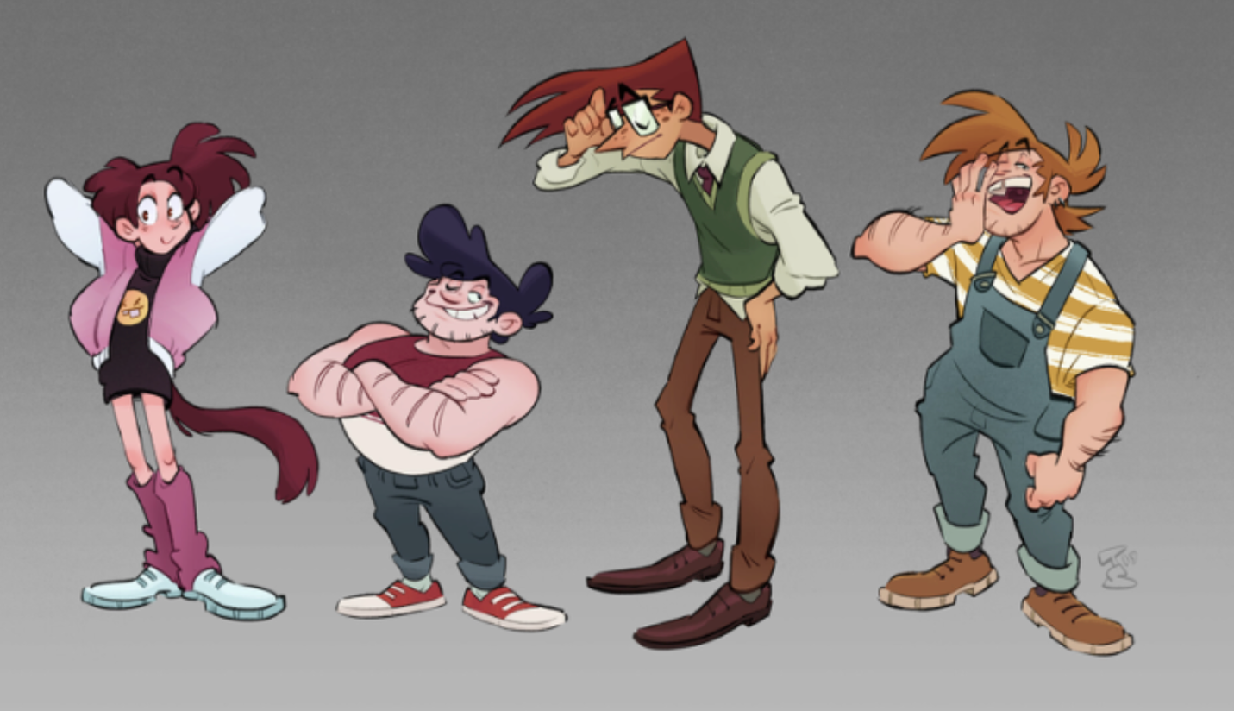

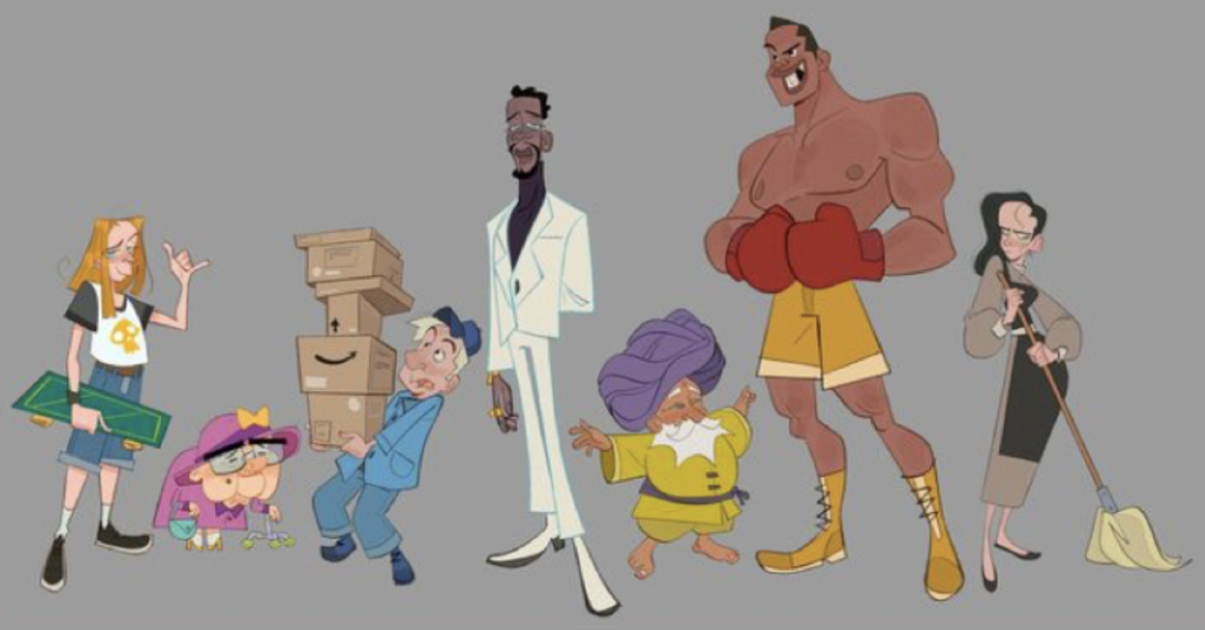

Summer Homework • Cartooning 2026
Instructors: Mr. Lassen; Mr. Roonan; Mr. Scaglione

RISING SENIORS
See slideshow of examples here – https://docs.google.com/presentation/d/1kWyC6iF_DMW-5axG9P9bMmRDPfL4y_v-i2yveI7THxc/edit?usp=sharing

Four-Panel Comics (webcomic style)
Make a four-panel (or more) comic once a week for the entire summer (starting the week of July 1th). See the next
page for samples, size, measuring.
Requirements:
• 8 comics at least (can be more!)
• It can be autobiographical, semi-autobiographical or based on the adventures of your own characters.
• You can create your comics digitally or traditionally.
• You can finish them rendered in black and white or color.
• Keep your gutters and overall size of each comic consistent throughout each piece. (This doesn’t mean you
can’t change the size of your panels if you need to but make sure each comic is the same size so it can be
collected potentially in a zine or book.)
If working digitally, use a square 8x8 inch canvas for webcomic style and 10x15 inch canvas for a traditional comic
book style orientation. Make sure your work is 300 DPI or more.

Comic Con Try-Outs (Optional)
Comic Con is the second week of October so we need to start preparing over the summer.
Think fan art and pieces that will be popular around the time of the con.
Have the following ready when we come back to school (We only need the designs)
• 3-5 prints
• Sticker Designs/Sheet (Sheet is a 8.5” by 5.5” page with 5 stickers on them).
• Professional Instagram Page

OPTIONAL
• Comics/cartoons
• Pins
• Charms
• Magnets
• Commission Sample
• Any other merchandising idea not listed below! Think outside the box!

