Film Department Summer Assignment
Description: Find 10 video clips (as YouTube links) that you feel exhibit strong filmmaking, and speak to you personally, and explain why. The video clips should be from a professional film or TV show. The strength of the film clip can relate to its cinematography, shot variety, editing, dramatic writing, etc.
Requirements:
1. No more than two clips can be from the same film or TV episode. We're looking for variety.
2. All ten YouTube links should be included in a single PDF document
3. Each link should include
● the name of the film or TV show that the link is taken from.
● the time code (section of the clip) that you are focusing on, for example 1:10 to 1:35.
● two or three sentences about what YOU think is strong about the film clip you selected and WHY it speaks to you.
4. You will upload your Summer Assignment to the Google Classroom Summer Assignment in the first week of film class.

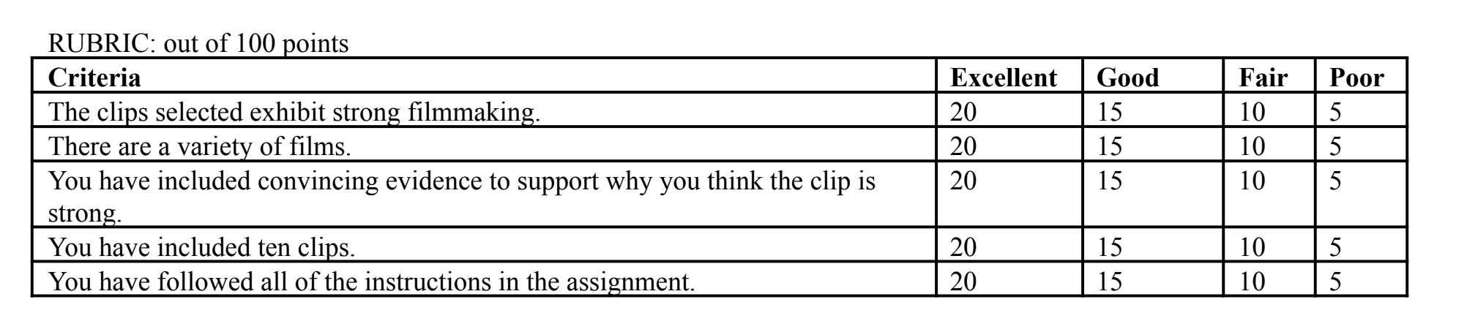

For any questions, please contact Mr. Harchol at hharchol@schools.nyc.gov and Mr. Bridenstine at mbridenstine@schools.nyc.gov

