‘Freshmen Foundation 2023 Summer Homework
Please, submit the Summer Homework assignments to your Foundation Design Teacher on the first day of school.
Project #1: "MY SURROUNDINGS"
Medium: Graphite
Size: 11” x 17, (or two 8.5” x 11 Facing Pages)
Directions: “My Surroundings” will be a representational drawing that you create based on the neighborhood environment you are familiar with. Using a camera, or phone take several photographs of different parts of your neighborhood. Then, using multiple photos design your neighborhood, drawing the scene on 2 facing pages in your sketchbook, or single 11”x17” drawing page. Consider how the focal point of your design will be most effective since the seam of your sketchbook will obstruct part of the view.
Project #2: "Still-Life"
Medium: Charcoal, or Graphite
Size: 11 x 14
Directions: Choose a room in your home that has good lighting (natural or artificial). Then, gather 3 to 5 items of interest to you that can be organized and set-up into an interesting still-life design. The items you select should provide insight to who you are, as you will create a still-life rendering of everything in the scene exactly as you see it. A rendering is a detailed drawing based on light and shadow, or light and dark values. Do not use, or add color.
Project #3: “SNEAKER DESIGN”
Medium: Markers, Pens, or Ink-Liners
Size: 8.5” x 11” (Black Sketchbook)
Directions: Design one pair of "Chuck Taylors" Converse sneakers using black, white and no more than 2 colors! The focus of your sneaker design is to create dynamic patterns consisting of rhythmic lines, contrasting shapes, and color that appears unified and balanced. You may use the Chuck Taylor Converse Sneaker Template below, or choose your own. Work directly on the print template or transfer the sneaker outline to your sketchbook before designing.
Your ability to create artwork based on the instructions provided above will serve as a base-line assessment of your current skills in regards to Drawing, Design, and Conceptual ability. Have a great summer and look forward to seeing you in September!
Foundation Design Instructors: Mr. Filardi, Ms. Jimenez, Mrs. Alexander, Ms. Singh
Freshmen Foundation 2023 Summer Homework
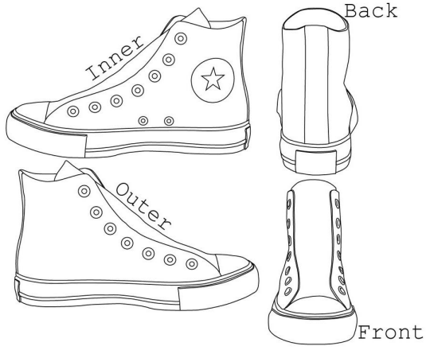Foundation Design Instructors: Mr. Filardi, Ms. Jimenez, Mrs. Alexander, Ms. Singh

