Table of Contents

Mission Statement 2
Parent Involvement Policy (from CEP) 3-4
School Responsibilities 5-6
Parent Responsibilities 7
Student Responsibilities 8
PTA and SLT Meeting Schedule 9
NYC Schools Account Information 10
Pupilpath and Website Information 11
Assessment, Homework, Grading 12
Arrival, Attendance, Transitions, Dismissal .13
Lockdown Procedures 14
Cell phone policy 15
School Calendar (draft) 16-17
A&D Student Bell Schedule 2020-2021 18
Graduation Requirements. 19
Programs Offered at A&D 20
Expected Behaviors 21-23
College Office 24
After-school Programs at ART AND DESIGN 25
Family Advocates/ Useful Websites 26
Remote/Blended Learning 27-48
.

The Art and Design Mission Statement
The mission of the High School of Art & Design is to inspire, educate, and fully prepare our gifted students to become exceptional artists. Through a unified curriculum that incorporates a broad spectrum of disciplines integrating art, technology and academics, our students are prepared to go on to college and careers with industry-standard mastery in the major of their choice. With a commitment to promoting strong ethical values and professional demeanor, we strive to foster a sense of community among our students, staff and parents. We are dedicated to engendering students' productive, creative and innovative participation in the world of visual arts as concerned and caring citizens of the global community.

2019-2020 PTA EXECUTIVE BOARD
AND SLT MEMBERS
** Elections for 2020-2021 to be held in the fall **

PTA Executive Board | School Leadership Team
Chevon Scott, 2nd Vice President  Wendy Lehmann and Jiin Win, Co-treasurers  Ricardo Fernandez, Asst Treasurer  Karen Rafael and Wendy Leonardo, Co-Recording Secretaries  Barbara Gordon and Deborah Croland, Co-Corresponding Secretaries  Co-Presidents, Vacant  Co-1st Vice Presidents, Vacant | Maximillian Re-Sugiura, Principal  Robert Robinson, UFT  Helen Vachicouras, CTE Teacher  Emory Davis, Teacher  Jose Contreras, DC37  Maria Larios, Parent  Gabrielle Gilliam, Parent Maria Larios, Parent  2 Student Vacancies

School Parental Involvement Policy
The High School of Art and Design encourages the participation of parents through membership on the School Leadership Team and Parent-Teacher Association. All parents are eligible to join and attend both groups. In addition, the Title I committee will be consulted regarding the use of Title I funds and will be involved in the development of the school's Title I Parent Involvement Policy and Parent School compact.

In order to build an effective home-school partnership, The High school of Art and Design will provide the following:

- A Parent/Student Handbook will be distributed annually to all students during the first week of school as well as freshman orientation/bridge program, giving students and their parents a clear understanding of the school mission, vision, and expectations for students.

- PTA and SLT meetings will be held throughout the year to assist parents in understanding the federal and state academic content and student achievement standards as well as the ART AND DESIGN policy of administering local academic benchmark assessments. PTA meetings and SLT meetings will take place the second Wednesday of each month. The schedule can be adjusted for school non-attendance days. Meetings will focus on how parents and teachers can work together to monitor a child's progress in order to improve student achievement.

- A PTA workshop will be held during the fall term for parents to network and receive training on navigating the New York City DOE website as well as Pupilpath and the new Art and Design website.

- The Student Government Organization will assist in planning annual events for parents and students such as periodic appreciation ceremonies, student Equity Leadership events, “I Applied Day,” for seniors, Family Nights, holiday events, the Spring Arts Festival, “I Decided Day,” Black History Month Celebration, Spanish Heritage Month, Lunar New Year, Eid Celebration and Women's History Month. Student government will also serve as a conduit for their fellow classmates to address pressing concerns and plan for the future.

- A minimum of two parent-teacher conferences (fall and spring) will be held to discuss student progress along with grade level information, curricula, testing expectations, and any other concerns that the teacher or parent may have. In addition, two Family Nights will be held. This year’s conferences are September 26, December 5 & 6, March 19 & 20, and May 21.

- Continuous communication will be maintained through Pupilpath, mailings, Weekly Reminders & Announcements each Monday, phone calls, the school website, text updates from Kinvolved, and periodic student achievement reports to assist parents in understanding school curricula, student achievement, and school-wide goals. All invitations will be sent in a timely manner with additional follow-up reminders via phone calls and our school website. The bi-monthly newspaper will be published in school and on the website. Academic alerts will be mailed home at the end of the second marking period each term for any student who has a 70% or under for an average of marking period 1 & 2 in each course.

- A school-parent compact has been designed by parents and school staff outlining how parents, school staff and students share the responsibility for improving learning for all.

- A Parent Involvement Survey will be distributed to all students at the beginning of the school year and will also be available at the first parent-teacher conference at the school. The school will compile and review responses regarding current programs and suggestions for improvement.

- Every effort will be made to communicate with parents in a format and language that is easily understood by all.

Parents and community members are always welcome at Art and Design.

ART AND DESIGN School-Parent Compact
Arts and Design High School, in compliance with the Section 1118 of Title I, Part A of the Every Student Succeeds Act (ESSA), is implementing a School-Parent Compact to strengthen the connection and support of student achievement between the school and the families. Staff and parents of students participating in activities and programs funded by Title I, agree that this Compact outlines how parents, the entire school staff and students will share responsibility for improved academic achievement and the means by which a school-parent partnership will be developed to ensure that all children achieve State Standards on assessments.
School Responsibilities
  - Art and Design is dedicated to providing a rigorous curriculum that is aligned with the Common Core State Standards/Career and Technical Education Skills Standards and is free from instructional barriers. It is our responsibility to support an effective learning environment that enables the participating students to meet and exceed the NYS student academic achievement standards as follows:
    - The school will provide high-quality core and arts curricula and instruction by hiring highly qualified teachers that meet NCLB Title 1 requirements.
    - The school will then, in a collaborative fashion, put together an academic program that meets or exceeds all mandated time requirements for the four core academic classes.

Rigorous curricula and instruction will be designed by staff in a collaborative fashion with the guidance of in-house professional development, district resources, and privately contracted educational entities as well as through our partnerships with arts and marketing design firms, CUNY, SUNY, The Office of CTE and the Office of Post-Secondary Readiness to ensure that instruction is differentiated to meet the varied skill levels of the students. Tutoring will be available after school. Students with high academic standing will be offered the opportunity to take college courses at CUNY’s Hunter College and the range of other CUNY sites after school as part of the College Now program.

  - Parents will be provided with consistent communication about their child's progress. Specifically, we shall furnish the following:
- Online access to Pupilpath to track the child’s ongoing progress through graduation, culminating in report cards six times a year.
- Parent-teacher conferences held four times per year as specified in the NYC DOE school calendar.
- Individual parent contact by teachers if a student is struggling; consultations with parents and guidance for suitable interventions to promote student success.
- Academic Alerts mailed at the end of the second marking period of each term for students in danger of failing for the term in each course.

  - Art and Design teachers will be made available to parents by phone or in-school conferences by appointment. Parental EnGagement (PEG) meetings will be held regularly.
  - Parents are invited to help in the planning, reviewing, and improving of the school's parental involvement policy in an organized, ongoing, and timely manner. This is accomplished through parental involvement in the SLT and PTA. The PTA will hold meetings to revisit and revise the school-parent compact, to discuss what progress is being made, and to decide on the allocations of funds through specially designed events eld in conjunction with the faculty and students of A&D. A calendar will be created and shared with all members of the Art and Design community via school website: www.artanddesignhs.org, weekly reminders & announcements and the parent newsletter and school Instagram page.
  - A meeting held in the fall will inform parents of participation in Title I, Part A programs and will explain the Title I, Part A requirements and the right of parents to be involved in Title I, Part A programs. Art and Design will convene the meeting at a convenient time for parents and will offer a flexible number of additional parental involvement meetings, such as in the morning or evening, so that as many parents as possible can attend. The school will invite and encourage all parents to attend.
  - Information will be provided to parents of participating students in an understandable and uniform format, including alternative formats upon the request of parents with disabilities, and, to the extent possible, in the preferred home language of each family.
  - Upon request, school-based Inquiry Teams and Data Specialists will provide pertinent non-confidential information about school data and how it is used to best serve our student population.
  - At the request of parents, Art and Design will provide opportunities for regular meetings for parents to offer suggestions and to participate, as appropriate, in decisions about the education of their children. Art and Design will respond to any such suggestions as soon as possible.
  - A Senior Letter Contract will be disseminated during the PTA conference in May (as Juniors) and in October (as Seniors) to ensure that all students and parents are aware of the requirements for graduation and the student behavior expectations in order to be able to participate in all senior activities.
  - Parents will be notified in a timely manner when their child has been assigned or has been taught for four (4) or more consecutive weeks by a teacher who is not highly qualified within the meaning of the term in section 200.56 of Title I.
  - Weekly professional development and instructional assessment tools will be provided to promote the continued educational advancement of all instructional staff.
  - School safety information will be disseminated, with designation of meeting locations in case of an emergency.

Parent Responsibilities
As an ART AND DESIGN parent, I will support my child's learning in the following ways:
- Monitoring attendance. I will call email my child’s guidance counselor to inform Art and Design when my child will be absent.
- Making sure that instructional assignments are completed in a timely fashion.
- Attending or chaperoning field trips (in-person and remote) intended to introduce students to post-secondary institutions in the 9th through 12th grades.
- Participating, as appropriate, in decisions relating to my child's education.
- Promoting positive use of my child's extracurricular time by ensuring adequate study time, encouraging participation in after-school events, and monitoring and limiting use of electronic devices.
- Staying informed about my child's education, academic progress, and behavior in the school building by accessing Pupilpath and attending PTA meetings and parent-teacher conferences.
- Providing my child with appropriate school clothing and monitoring what is worn daily.
- Maintaining lines of communication with the school by promptly reading all mailed, emailed and child-delivered notices from school and responding when appropriate.
- Notifying the school regarding any pertinent changes in my child's well-being that may affect my child’s performance in school.
- Notifying the school about change of guardianship and contact updates (address, phone numbers, etc.).
- Becoming involved in developing, implementing, evaluating, and revising the school-parent involvement policy and compact.
- Serving, to the extent possible, on policy or school advisory groups that may include the SLT, the PTA, the Title I Policy Advisory Committee, and the District-wide Policy Advisory Council.

If you have any questions or concerns, please contact your child’s guidance counselor or the parent coordinator. The contact information is below.
Ayoka Cox: 9th Grade Guidance Counselor
Nicholas Reyes: 10th Grade Guidance Counselor
Melissa Montero 11th Grade guidance counselor
Lauren Pace: 12th Grade guidance counselor
Janeen Johnson: Parent Coordinator

Student Responsibilities
As an Art and Design student, I will share the responsibility to steadily improve my academic achievement and meet or surpass the state's highest standards for success.
Specifically, I will:

Be in school every day and on time.
- Work toward completing my assigned tasks every day and ask for help from teachers, parents or peers when necessary.
- Use my creative talents as a lens to reflect my unique worldview.

- Give my parents all notices and information received by me from my school.

- When possible, engage in extra-curricular activities such as clubs, sports, and/or student government.

- Promote a positive tone within the school building through my words and actions.

- Refrain from engaging in physically destructive acts such as graffiti or destruction of school property.

- Attend PM school or tutoring sessions as needed and participate in other services provided by Art and Design or community-based organizations to receive academic tutoring and/or test preparation.

- Follow Art and Design rules and DOE discipline codes.

- Promote a safe and effective learning environment for all students.

- Participate in after-school peer tutoring and mediation programs.

- Respect all members of the Art and Design community, including fellow students, teachers, administrators, staff, and parents.

- Wear proper school attire. Tube tops, do-rags, hoodies, short shorts, short dresses, midriff-baring shirts, and sagging pants are prohibited.

- Keep my phone out of sight and refrain from using it in classes, as per the school’s phone policy. Phones are allowed in the building, but they are not to be seen in classes unless serving a specific academic purpose as assigned by your teacher. (Parents, please refrain from calling your child during the school day. If there is an emergency, please contact the main office.)

A&D SLT and PTA Tentative* Meeting Schedule
SLT Meetings—4:30 P.M.-6:00 P.M.
PTA Meetings—6:00 P.M.-7:00 P.M.

All SLT/PTA meetings are held on the second Thursday of the month unless otherwise noted. Parents will be informed five days prior to any meeting changes.
September 10, 2020 | February 11, 2021
October 8, 2020 | March 11, 2021
November 12, 2020 | April 15, 2021
December 13, 2020 | May 13, 2021
January 14, 2021 | June 10, 2021

*Based on NYC DOE active Calendar TBD as of 8/25/2020

NYC Schools Account
With a NYC Schools account, you will have access to a large amount of information about your child. You will be able to see;
- Attendance – View your child’s attendance for the current school year, including the number of days he or she was late or absent.
- Grades – View your child’s report card grades and any teacher comments for each marking period in the current school year.
- Student Profile – View the contact information on file at your school for you and your child.
- Additional information: Test scores, schedule, etc.
How do I create an account?
You must be your child’s parent or legal guardian and live at the same address to create an account. If you have more than one child attending a NYC school, you can create an account for all of them in one visit.
- Set up an appointment with your child’s school.
- Bring a working email address and ONE of the following photo identification cards:
Passport Driver’s license IDNYC
For additional information on obtaining a photo ID, visit http://www.nyc.gov/idnycWelcome NYC Parent or Guardian.
You can register for a free email address through Gmail, Yahoo, or Hotmail.

- Set up an account with the parent coordinator and receive a temporary password. When you create the account at your school, you’ll receive a receipt with your temporary password printed on it.

- Sign into your account from a computer, phone, or tablet.
Go to http://schools.nyc.gov/myaccount and enter your email address and temporary password. You will be asked to create a new personal password for your account.
Additional Help
NYC Schools is available on any internet-ready device, including tablets and smart phones. If you need access to a computer, visit your nearest public library.
If you need more assistance or have questions about navigating your account, contact your child’s school or call 311.

Learn more by visiting: http://schools.nyc.gov/nycschools.

Pupilpath
Pupilpath is an online grade book program used by A&D to improve the connection between home and school. Pupilpath allows students and parents to check current grades as well as individual assignments and scores online anytime.
How does it work? Teachers post assignment descriptions and grades in their online grade books. With your secure access, you can access a one-page summary of your child’s current grades for all classes. Pupilpath makes it easy to stay informed every day. If you need further assistance with Pupilpath grades please contact our parent coordinator, Ms. Janeen Johnson at JJohnson32@schools.nyc.gov.

How do I get into Pupilpath?
After receiving your password:
- Go to https://pupilpath.skedula.com/
- Click the “Student Register” button at the bottom of the screen.
- Select 02M630 Art and Design, Type in your ID, Date of Birth and Registration Code.
- Choose a new password.

Our School Website
Our school website is full of information, including a calendar of specific events, test schedules, messages, and teacher contact options.
How do I get onto the school website?
- Go to www.artanddesignhs.org.
- Explore all info on school website and contact Ms. Johnson, at JJohnson32@schools.nyc.gov with questions.

Assessment, Homework, Grading
Assessment
In addition to the state- and city-wide standardized tests, Art and Design uses the following to assess student learning:
  - Observing student work and conversations
  - Collecting and evaluating student work done in class and at home
  - Giving quizzes and tests periodically (Twice per marking period & 4 times per year for benchmarks)
  - Requiring students to evaluate their own work and level of understanding
  - Evaluating student understanding through projects and simulations
  - Administering Common Core State-Approved performance tasks.

Homework
We believe that for fully in-person learning, homework helps students to deepen their understanding of skills and concepts introduced in class, builds independent learning skills, and prepares students for the rigors of college. Research supports this belief.

As for how much homework students will have, the Chancellor’s Regulations require a minimum of two to three hours of homework daily for high school students.
Just as with class work, homework should be done thoroughly, neatly, and carefully. Homework presentation and quality will have an effect on a student’s grade.

Grading
Students will receive report cards every marking period and will be graded according to the grading policy received from teachers. Students can view their progress towards a final grade by logging into https://pupilpath.skedula.com/ at any time. Parents will receive their own password to monitor their child’s grades.

Arrival, Attendance, Transitions, Dismissal
Students need to come to school every day on time. If a student is not able to come to school, a parent or guardian must call the school at (212) 752-4340, on the morning of the anticipated absence and state the reason. Whenever possible, doctor and other essential appointments should be scheduled for after school.

All students are required to be in school no later than 8:52 A.M. Students are expected to arrive on time.

GETTING TO SCHOOL: When and Where
  - Swipe your school ID through the CAASS system upon entry and get your temperature checked.
  - Breakfast will be served from 8:30 A.M. to 8:52 A.M.

You must report to class no later than 8:52 A.M.

What if I’m late?
  - If you arrive to class after 8:15 AM, you will be marked late.
  - If you are late, you should get a late pass upon swiping in.
  - If you arrive after 10:00 A.M., you must go to the main office (Room 304) to get a late pass and place a call to your parents to inform them that you’ve arrived late to school. You can then go to your scheduled class.

What if I’m absent?
A parent or guardian must call ART AND DESIGN at the day of the absence to leave a message with the attendance secretary or on the answering machine.
When you are absent, you need to bring a written note from your parent or guardian or appointment place explaining the absence on the day you return.

If you have three unexcused absences during one month, your parent/guardian will be required to attend a conference with the guidance counselor and the principal to develop improvement plan.

What if I need to leave early?
If a student needs to leave early for a doctor’s appointment, college interview, etc., the parent must notify the school in writing via a written note or email to their child’s guidance counselor indicating 1) their relationship to the child, 2) time to be dismissed, 3) purpose of early release, and 4) phone number where the parent can be reached. The school will match the parent’s phone number/email address with data included on the child’s blue emergency card and confirm the early release by telephone.

What are the bathroom- and water-request procedures?
Each time a student leaves the room, they must sign the “out-of-classroom log” kept in each teacher’s room.

Students MAY NOT leave a classroom during:
-the first 5 minutes of class
-the last 5 minutes of class

LOCKDOWN PROCEDURES

In the event of an incident, you may hear the following terms announced over the PA:

“Soft Lockdown”
Lockdown is the procedure of locking classroom doors, pulling blinds to cover outside windows, and blocking the view through any windows in the door or between the classroom and hallway. A Soft Lockdown is when students are locked in their classrooms, seated along a wall out of sight of windows and doors. Lights are turned off and no teaching is done until the threat passes. A Soft Lockdown implies that there is no identified imminent danger to the sweep teams.

“Hard Lockdown”
A Hard Lockdown is when students are locked in their classrooms, seated along a wall out of sight of windows and doors. Lights are turned off and no teaching is done until the threat passes. A Hard Lockdown implies that imminent danger is known and NO ONE will engage in any building sweep activity.

“Shelter-In”
A Shelter-In is employed when there is a threat outside the school but no immediate threat to students or staff inside the school. During a Shelter-In, the building perimeter is secure and staff is stationed at the doors to be sure no one goes in or out of the building.

We will remain in this state until the following signal is announced:

“All Clear”

EVACUATION LOCATIONS (Subject to change for 20-21)
In case of an emergency, students and staff from our school will be evacuated in keeping with the designated locations in the school safety plan. These locations, where possible, will provide shelter to students and staff.

TYPE OF SITE | SITE TO BE USED | LOCATION | CONTACT PHONE
Primary | Cathedral High School | 350 East 56th street | (212) 688-1545
Secondary | M480 JULIA RICHMAN ED. COMPLEX - M | 317 EAST 67 STREET , MANHATTAN, NY 10021 | (212) 570-4018
Out of Area | M600 FASHION INDUSTRIES VOC HS - M | 225 WEST 24 STREET , MANHATTAN, NY 10011 | (212) 255-1235

Cell Phones / Communication Devices
Chancellor’s Regulation A-413 governs the use of cell phones, computing devices and portable music/entertainment systems on school property.
The regulation is as follows:
- Students are permitted to bring the following electronic items to school: cell phones, laptops, tablets, iPads, and other similar computing devices (“computing devices”), and portable music and entertainment systems.
- Each principal must establish a written school-based policy regarding the use of such electronic items that is consistent with the regulation, and must consult with the School Leadership Team.
ART AND DESIGN Cell Phone Policy:
- ART AND DESIGN students are permitted to bring cell phones to school.
- Students may use their cell phones in the hallway, library, lobby and cafeteria.
- When the teacher allows, students may use cell phones within the classroom for instructional purposes.
- If a student is caught using a cell phone or electronic devise during instruction without the teachers permission the following steps will be followed:
  - Teacher warning to put device away.
  - Teacher will call home to contact the parent.
  - The dean will be called to speak with the student.
  - The dean will confiscate the device until the end of the day and contact the parents
  - Parent will be called in for a conference and takes the device.
  - Student will drop the device off with the dean at the start of each day and pick it up at the end of each day for two consecutive weeks.
- It is important that students are not distracted by constant messages or phone calls so that they can focus completely on instruction. Therefore, please refrain from calling or texting your child while (s)he is in class.
- If there is an emergency, please call the main office at (212) 752-4340 and your child will be given the message and call you if necessary.
- If you are concerned that your child’s phone can be stolen or that (s)he will be distracted by having it during the school day, please advise him/her to deposit the phone with the parent coordinator in the morning and pick it up after school.
- In case of emergency, students are always allowed to use school phones in the main office.

Art and Design School Year Calendar 2020-2021

September 10 | Thursday | First Day of School
September 17 | Thursday | SLT and PTA Meetings
September 30 – October 1 | Monday-Tuesday | Rosh Hashanah – School Closed
October 8 | Thursday | SLT Meeting, 4:30 – 6:00 P.M.  PTA Meeting, 6:00 – 7:00 P.M.
October 9 | Friday | Yom Kippur – School Closed
October 14 | Monday | Columbus Day – School Closed
October 18 | Friday | End of Marking Period 1
November 5 | Tuesday | Election Day – No students in attendance: Chancellor’s Conference Day for staff development
November 11 | Monday | Veterans Day – School Closed
November 12 | Thursday | SLT Meeting, 4:30 – 6:00 P.M.  PTA Meeting, 6:00 – 7:00 P.M.
November 27 | Wednesday | End of Marking Period 2
November 25 - 27 | Wednesday - Friday | Thanksgiving Recess – School closed
December 5 | Thursday | Parent-Teacher Evening
December 6 | Friday | Parent-Teacher Afternoon
December 13 | Thursday | SLT Meeting, 4:30 – 6:00 P.M.  PTA Meeting, 6:00 – 7:00 P.M.
December 24 – January 1 | Tuesday – following Wednesday | Winter Recess, including Christmas and New Year’s Day – School Closed; Students return on Thursday, January 2
January 14 | Thursday | SLT Meeting, 4:30 – 6:00 P.M.  PTA Meeting, 6:00 – 7:00 P.M.
January 17 | Friday | End of Marking Period 3
January 20 | Monday | Dr. Martin Luther King, Jr. Day – School Closed
January 27 | Monday | Chancellor’s Conference Day – No school for students
January 28 | Tuesday | Spring term begins

Art and Design School Year Calendar 2020-2021

February 11 | Thursday | SLT Meeting, 4:30 – 6:00 P.M.  PTA Meeting, 6:00 – 7:00 P.M.
February 17-21 | Monday - Friday | Mid-winter recess, including Washington’s Birthday and Lincoln’s Birthday, DOE observed— school closed
March 11 | Thursday | SLT Meeting, 4:30 – 6:00 P.M.  PTA Meeting, 6:00 – 7:00 P.M.
March 13 | Friday | End of Marking Period 4
March 19 | Thursday | Parent-Teacher Evening
March 20 | Friday | Parent-Teacher Afternoon
April 8 | Wednesday | SLT Meeting, 4:30 – 6:00 P.M.  PTA Meeting, 6:00–7:00 PM
April 9-17 | Thursday-following Friday | Spring recess— school closed
May 1 | Friday | End of Marking Period 5
May 21 | Thursday | SLT Meeting, 4:30 – 6:00 P.M.  PTA Meeting, 6:00 – 7:00 P.M.
May 25 | Monday | Memorial Day observed— school closed
June 4 | Thursday | Chancellor’s Conference Day for staff development – No School for students
June 10 | Wednesday | SLT Meeting, 4:30 – 6:00 P.M.  PTA Meeting, 6:00–7:00 PM
June 16 | Tuesday | End of Marking Period 6
June 26 | Friday | Last day for students

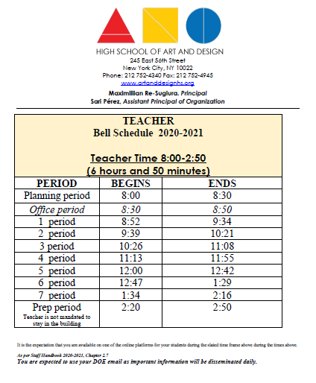

ART AND DESIGN Graduation Requirements

You must earn a minimum of 44 credits to meet graduation requirements, as indicated here.  *Arts Commencement Criteria Minimum | Regents Diploma | Advanced Regents Diploma
English | 8 credits | 8 credits
Social Studies | 8 credits | 8 credits
Mathematics | 6 credits | 6 credits
Science | 6 credits | 6 credits
Foreign Language | 2 credits | 2 credits
Arts/CTE* | 10 credits | 10 credits
Health | 1 credit | 1 credit
Physical Education | 4 credits | 4 credits
Total Academic Credits | 45 credits | 45 credits

Regents Exams Required for Advanced Regents Diploma
3 Math Regents exams
2 Science Regents exams
1 Social Studies Regents exam
1 English Regents exam
1 Additional Regents in any area
1 L.O.T.E. (Language Other Than English Exam)

Regents Exams Required for Regents Diploma
1 Math Regents exam
1 Science Regents exam
1 Social Studies exam
1 English Regents exam
1 Additional Regents in any area

Regents Exams Required for Local Diploma
Only IEP students or students with 504 accommodations will qualify for a local diploma if they earn a score of 55% or above on all of their Regents exams.

Programs Offered at ART AND DESIGN

College Now
Students earn up to 9 tuition-free college credits by graduation. Students can take up to 3 College Now courses (equal to 9 college credits) at our nearby sister-school SUNY, Hunter College.
Student eligibility is based on earning at least 75% on the English Regents exam.
** All students that earn at least a 75% are expected to take college courses regardless of which track they apply to take.
Students may also take two additional College Now courses to earn six additional credits at the Baruch College campus during the summer or after school.

CAREER AND TECHNICAL EDUCATION (CTE) NYS ENDORESED DIPLOMA:
Arts
Students complete a minimum of 8 CTE-oriented art courses that align to their selected artistic major-focus in addition to standard academic requirements.
Majors include: Animation, Architecture, Cartooning, Fashion Design, Filmmaking, Graphic Design, Illustration and Photography.

A.M Arrival:
Expected Behaviors

- Arrive to school on time.
- Enter the building quietly.

Remove hats and outer garments.
- Turn off and put away all electronics. Remove headphones.
- Listen silently during any announcements.
- Submit a note from a doctor or parent for every absence to the main office and contact guidance.

Hallway/Stairwell:
  - Leave classroom from assigned door.
  - Be quiet.
  - Be calm.
  - Walk directly to your next class.
  - Avoid physical contact with other students.
  - Follow directions on doors and stairwell walls.

Classroom:
  - Upon entering class, take your seat and begin engaging with your remote tasks.
  - Place backpacks under or on the back of the chair.
  - Raise your hand, not your voice.
  - Remain in your seat, unless you are directed to small group instruction.
  - Complete all class work and homework within your power during school hours.
  - Focus and stay on task – avoid distractions.
  - Wait for dismissal by teacher from assigned door.

Substitute Teacher:
  - Treat substitutes with respect; they are regular teachers.
  - Remain in the room for the entire period.
  - Complete all work, which will be collected and graded by the subject teacher.
  - Follow all regular classroom and school rules.

Lunch Hubs:
  - Pick up from the lunch hubs before your schedule 4th or 5th period classes.
  - Stand quietly on line to receive your meal.
  - Pay attention to supervising staff.
  - Upon entry to your next class, remain seated.
  - Keep the eating area clean.
  - Finish all food before leaving the lunchroom; do not bring food outside the classroom.
  - Respect your Custodial Engineers by making sure all garbage is disposed of properly.
  - Remain in the building during lunch.

P.M. Dismissal:
  - Remain in seat; wait for teacher’s instructions for dismissal.
  - Collect personal belongings to be taken home daily or stored in lockers.
  - Walk quietly to exit.
  - Leave the building and school area promptly.

Fire Drills:
  - Maintain absolute silence in and out of the building.
  - Hold banister.
  - Line up and walk silently.
  - Leave book bags in classroom.
  - Watch and listen for instructions.
  - Make note of which staircase you should be using.
  - Leave, remain, and return with the class.
  - Stay with your teacher.

School Trips:
  - Remember, you are representing Art and Design; all school rules apply.
  - Conduct yourself in an orderly manner at all times.
  - Follow all directions given.
  - Do not consume food/beverages on the bus or train.
  - Stay with your group.
  - Listen to ALL adults.
  - Respect ALL your peers.

- City Bus/Contract Bus:
  - Act appropriately so as not to jeopardize your safety or the safety of others.
  - Keep body parts and other objects inside bus and train.

- Lockers
  - Use lockers only during entry or after school.

- Community:
  - Respect property as if it were your own.
  - Dispose of all trash properly.
  - Stay on sidewalks.
  - Be aware of others around you and your surroundings.
  - Cross in crosswalks with lights.

- General Rules:
  - Respect the rights and property of others.
  - Wear proper school attire. Prohibited items: Hats, hoods, do-rags, spaghetti straps, tube tops, low-cut shirts, short shorts, and sagging pants.
  - Carry I.D. at all times.
  - Arrive on time to all classes, assemblies, and the cafeteria.
  - Bring pens, pencils, notebook(s), and any other required supplies and textbooks daily.
  - Do not deface school property. Graffiti is strictly forbidden. This includes, but is not limited to: walls, books, desks, doors, and bathrooms.
  - Obey all adults in the building.
  - Use appropriate language at all times.
  - Do not chew gum anywhere in the building.
  - Eat food in the cafeteria only.
  - Remain in the cafeteria until instructed to go upstairs by a supervisor.

XIII Safety Rules:
- Handheld electronic games are only to be used in the cafeteria or before and after school.
- Student guests are forbidden.
- Do not wear outer garments during school hours. This includes, but is not limited to, hats, scarves, headgear, and jackets.
- Fighting of any kind, including horseplay, is forbidden.
- Drugs and alcohol are forbidden.
- Smoking is prohibited anywhere in the school building or schoolyard.
- Tampering with devices, such as the fire alarm or the lights, is absolutely forbidden.
- NYC School Regulation states: “Carrying a weapon in a school building poses a clear and present danger to other students. This includes: knives, penknives, razors, box cutters, letter openers, BB guns, and any other object that can be used as a weapon.”

The Art and Design College Office

The College Office helps students of A&D to achieve their academic and post-secondary career goals. The College Office offers individual college counseling and advocacy, campus visits, workshops on the application and financial aid processes, seminars for parents and teachers, and SAT/ACT prep classes. The College Office is staffed by a full-time college advisor, who provides both group counseling and individual advising. All students will have access to the College Office, which is located in room 602.

The college advisor will also be supporting upperclassmen in Portfolio Review classes.
In these classes, students will explore careers and colleges that meet their interest, complete their college applications to CUNY, SUNY, and private colleges, apply for FAFSA and scholarships, refine their college essays, and learn interview skills with the college representatives.

The following is a schedule that shows when applications will be completed in the senior classes:

September: SAT/ACT registration · October: CUNY applications · November: SUNY applications· December: Private college applications.
Please note that while this is the schedule the class will follow, it is up to the individual student to keep track of all application dates and deadlines. If the student is applying to a college with an application deadline before the schedule above, it is the responsibility of the student to bring that to the attention of the college advisor, in writing via email.

Application fees
City Universities of New York (CUNY): $65 (six college choices included)
State Universities of New York (SUNY): $50 per college choice
Private Colleges: Varies depending upon the college
*Fee waivers may be available to SUNY and private colleges on a first-come, first- served basis and based on demonstrated financial need.

Please feel free to contact the College Office at (212) 752-4340 ext 60201 with any questions.

After-School Programs at Art and Design

Program Description:
Art and Design provides quality youth development opportunities to our students directly after school. These programs are supported by school, community, public, and private partnerships. Our after-school programs offer a broad range of educational, recreational, and cultural age-appropriate activities that integrate what happens during the school day. Youth and family involvement in program planning and implementation is a key component. Programs operate four days a week (Tuesday-Friday) 2:35- 5:00 P.M. during the regular school year and may elect to operate during school breaks. Programs may also extend into the evening hours.

Academic Services:
Services available include after-school tutoring, peer tutoring, PM School and (pending) Regents prep. These instructional services are embedded in the culture and climate of our school.

Clubs and Activities:
The Art and Design after-school program promotes academic success as well as the importance of cultural, creative, athletic, and service activities. The following clubs and activities are offered: PSAL (boys/girls: soccer, volleyball, basketball, baseball/softball and bowling), student government, Dungeons and Dragons, AND Agency, chess, GSA, Dance, Weight training, and Green Team to name a brief few. Besides the numerous activities and clubs that are held throughout the week, there are special days and events which are held throughout the year, including our Spring Arts Festival, the Art and Design PTA Fan Faire, various trips, movie days, field trips, and staff-student sports.

Trips and Events:
As a participant in the Art and Design after-school program, students are routinely taken on trips to various cultural sites, athletic events, and recreational activities. Recent trips have included The Metropolitan Museum of Art, The Museum of Modern Art, Central Italy, The Art Students League, Comicon, MOCCA, The Museum of the Moving Image, The Bronx Zoo, and numerous college tours. A signed Parent Consent Form is required for every trip.

Family Advocates

FACE— Division of Family and Community Engagement
49 Chambers Street
Room 503
New York, NY 10007
Telephone: 212-374- 4118
Fax: 212 374 0076
face@schools.nyc.gov

District 2 Family Engagement
Damaris Frias, Family Leadership Coordinator
333 7th Avenue-Room 710
New York, NY 10001
212-356-3881
dfrias@schools.nyc.gov

Useful Websites:

NYC Family Guides in Many Languages: http://schools.nyc.gov/ParentsFamilies/
NYCFamilyGuide.htm

NYC Schools Account: https://schools.nyc.gov/myaccount

School Website: www.Universityneighborhoodhs.org
This website provides clear, consistent expectations for what students should be learning at each grade level in order to be prepared for college and career.

Parents’ Guide to Student Success: CoreStandards.org/In-The-States

New York State Department of Health Website:
www.nyhealth.gov/prevention/immunization/information_system/
If you have questions or concerns, contact your child's doctor. Also, you may con- tact the Growing Up Healthy Hotline by calling 1-800-522-5006 or through TTY ac- cess at 1-800-655-1789.

New York City Well: NYC.gov/nycwell 1 (888) NYC-WELL

Remote/Blended Learning Addendum

Resources can be found in the remote learning section of the school’s website

Contacts

Contacts for Remote/Blended Learning:
We are here for you 100%. Whatever you need, please reach out to us day or night for support!
- Technology Issues: Fahsan@schools.nyc.gov
- General Information or Concerns: Jjohnson32@schools.nyc.gov
- Academic Concerns: 9th Grade - Ms. Cox acox@schools.nyc.gov
- Academic Concerns: 10th Grade – Mr. Reyes Nreyes@schools.nyc.gov
- Academic Concerns: 11th Grade - Ms. Montero mmontero@schools.nyc.gov
- Academic Concerns: 12th Grade – Ms. Pace Lpace@schools.nyc.gov
- Discipline and Social Issues: Mr. McCalla, Assistant Principal bmccall2@schools.nyc.gov
- Assistant Principal of Math and Instructional Support – Ms. Budney tbudney@schools.nyc.gov
- Assistant Principal of English, Social Studies, World Language– Ms. Rosales lrosales@schools.nyc.gov
- Assistant Principal of Arts and CTE – Ms. Reingold Ereingo@schools.nyc.gov
- Assistant Principal of Guidance and Sciences – Ms. Daly Mdaly6@schools.nyc.gov
- Principal: Maximillian Re-Sugiura mresugiura@schools.nyc.gov
Blended/Remote Learning Schedule
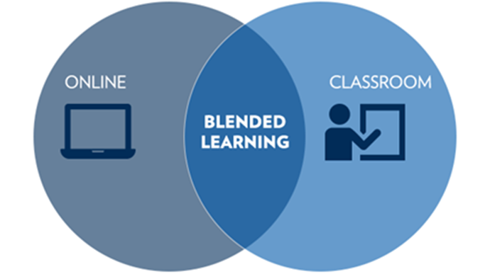
Due in part to the success of Remote Learning in the Spring of 2020, Art and Design will be making strategic shifts to improve areas that required additional consideration (see below). Here are the key notes for the schedule
- Students will attend school in the Blended Learning Model twice every six days.
- Students will be assigned activities on home days and will complete them along with assessments and challenge activities with their teacher in person utilizing the flipped classroom model.

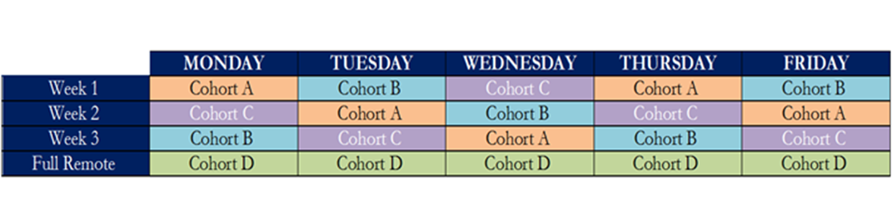
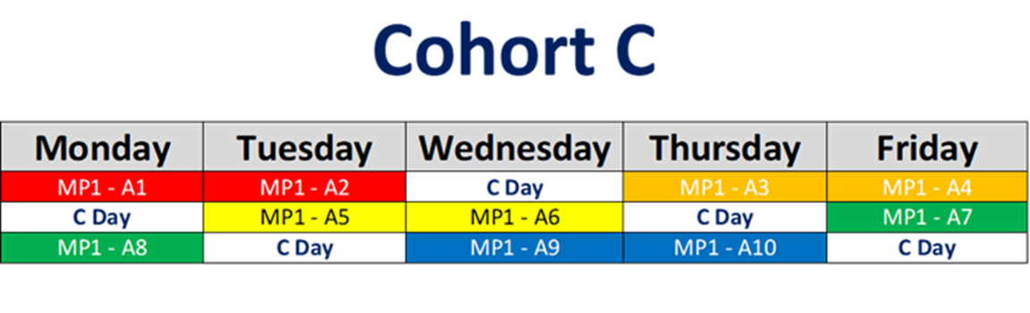
► Each assignment, including watching of any support video/explanation, should take no more than 30 minutes in core classes
► Each cycle will have 10 assignments; each marking period will have two cycles (20 assignments per class, per marking period)
Blended/Remote Learning Cycle of Assignments by Cohort
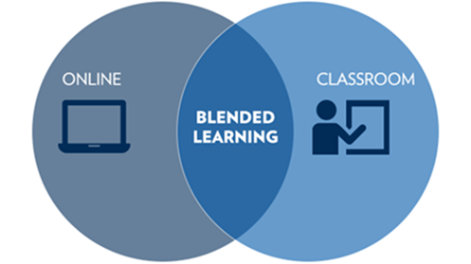

► Assignments for each class will be labeled with the cycle and assignment number. Example: MP1.A4 – Factoring Quadratics.
► Remote instruction students (Cohort D) are paired with Cohort A students (DOE/UFT Agreement Permitting) in each class through Zoom for assistance. Will rotate each MP.

Students will be assigned cohorts when they receive their schedules in late August! Stay tuned for an email via Pupilpath!

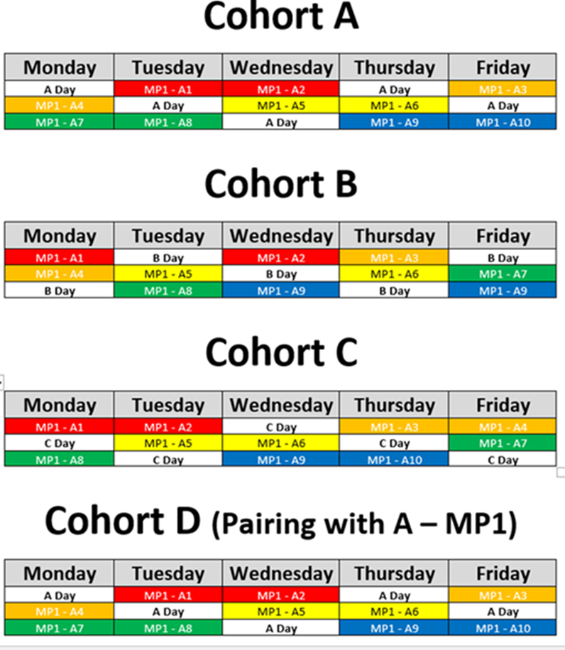

Instructional Expectations in Blended/Remote Learning
► This model of classwork and homework applies to core classes. As arts classes are generally double periods for 10-12th grades and will reflected an adjusted number of assigned tasks and assessments.
► Assignments will be given for students to complete independently on Home Days in each class
► Each assignment will have an instructional video/reading/creating component and activity that includes additional resources such as access points
► Each assignment, including watching of the video, should take no more than 30 minutes in core classes
► Each cycle will have 10 assignments; each marking period will have two cycles (20 assignments per class, per marking period)
► Assignments for each class will be labeled with the cycle and assignment number. Example: MP1.A4 – Factoring Quadratics.
► Home instruction students (Cohort D) are paired with Cohort A students (DOE/UFT Agreement Permitting) in each class through Zoom for assistance. Will rotate each MP.
► When a student arrives to class, they will be asked to open the laptop and begin working on the assigned task.
► Students will then be formatively assessed on their knowledge of the assignments by their teachers through white boards, kahoot, quizlet, quizzes, etc. Students that need additional assistance can be assigned small group instruction with the teacher.
► Students can then improve their content knowledge and correct any misconceptions on their own, with their classmates, by the aid of access points or place themselves in to small group instruction.
► Images below will assist you in understanding the system for the “Flipped Classroom – Blended Learning Model”
► Proposed Grading Policy Draft (based on SLT agreement):
Cycle Assignment Participation/Completion – 80%
Assessment (with Test Corrections) – 20%

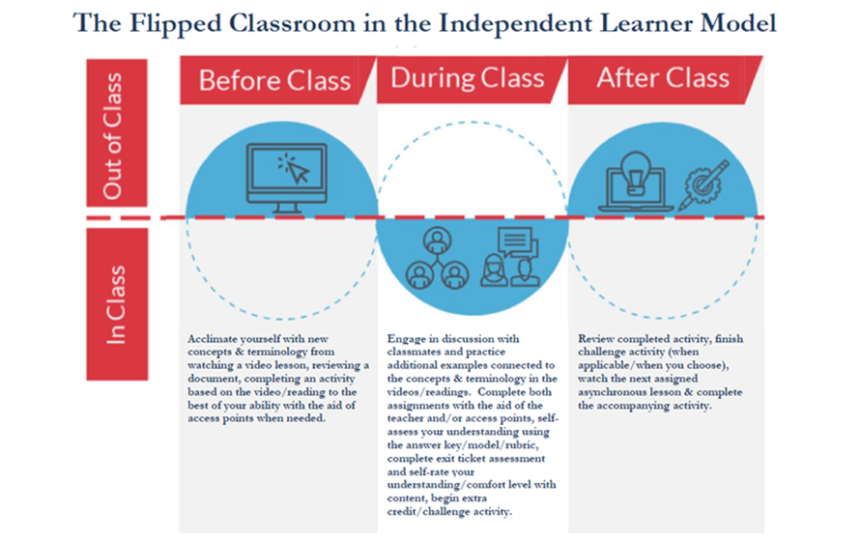

Culturally Responsive – Sustaining Blended/Remote Education

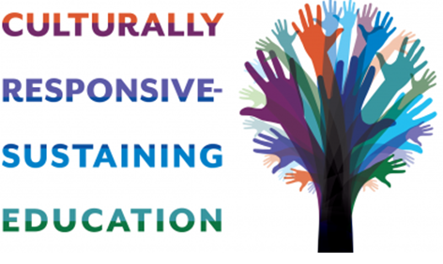
Art and Design represents what a school can become when rigorous artistic education meets an informed, equitable lens on society and policy. We are, as many others in the Manhattan High School family, an antiracist school. That means that we will use our power, position, talent and privileges to address and disrupt racist policies that create barriers and disenfranchise any member of our society based on the color of their skin. The Equity Team at Art and Design represents a union of faculty and students. We have made Equity a priority for many years, holding professional development sessions about race, equity, and gender, about the importance of standing up for what is right. We have read multiple articles and attended Professional Learning as a staff around Anti-racism, activation and the history of White supremacy. We have been working on modifying curriculum to make sure we incorporate the voices and perspectives of people of color, diversified our classroom libraries, and held discussions about race and justice in our classes, though they will be increasing and more intentional and school-wide in the next school year. Feedback from our young professionals and their families is critical to our evolving conversation and reflection on what it means to disrupt racist policies that have shaped our world.
The Manhattan Superintendency under Executive Superintendent Rosales and Superintendent Orlen have been leaders in this work in our city for many years, and they have been in the forefront of moving toward building equitable schools for all students across Manhattan. The work is never done. We will work to get better every day. But I am so blessed to lead this school community with the absolute best faculty and staff in New York City. I would put us against any staff out there.
For the next school year, we will complete the reading and analysis of How to Be an Antiracist by Dr. Ibram X. Kendi as a staff. We have started this work during the Spring and summer and we invite all students and families to join us in our reading and discussions around the text. Please email me if you are interested in joining us as we continue to further our conversation and collectively read texts that address bias and racism.
You don’t have to be a leader in the conversation, but simply a participant in creating a safe space where others can listen and provide their worldview.

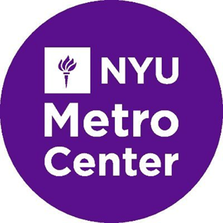
What are four (4) things that educators and families should be thinking about to minimize the socioemotional and mental toll of/anxieties caused by this social emergency?
- Breaks in between school work; have a well-planned day with every day routines established
- Mindfulness (e.g., Liberate: Meditation and Mindfulness App: https://liberatemeditation.com/)
- Regular check-ins and the giving of space for students to talk about how they are feeling and how they are adjusting to the change; create a safe environment to express feelings and thoughts (e.g., Pod Mapping for Mutual Aid; Source: the Bay Area Transformative Justice Collective: https://batjc.wordpress.com/pods-and-pod-mapping-worksheet/)
- A virtual support group for parents (it can get overwhelming)

What are two (2) things that educators and families should be thinking about to maximize feelings of belonging, connectedness, worth, and learning?
- Ideas for parents on how to spend the day with their children being at home 24/7 (For example, parents should take advantage of their children being at home to help them to organize their area of work)
- Strategies and structures for building remote communities through online platforms, video chats, conference calls, outdoor exercise, etc.
What do we need to know about culturally responsive-sustaining remote education?
Teachers need to know . . .
- How race, ability, class, language, gender, and other systems of identity influence learning, access to learning, and how we should think about education
- How power can translate to online environments (e.g., do boys and young men take up more space than girls and young women; does instruction privileged abled persons in ways that it does not privilege otherly abled persons, etc.?)
- How to ensure full participation from all students
- How to prioritize and address the questions/doubts raised during a lesson
- How to set a structure around continuous assessment and progress monitoring
- Lesson planning effectively with others (partnering with students, parents, and other educators) which provides scope and space for online activities and remote participation
- Different students have different learning pace and requirements
- Building student morale is very important as this is new and uncharted territory for students as well
- How to use multiple online and social media platforms so they can be flexible with which ones work best for their students
- How to communicate with and build meaningful relationships with families from different racial, cultural, linguistic, ability, and class backgrounds (Teachers need to pick up the phone and call parents and students; however, they rarely feel comfortable talking one-on-one and tend to lack the relationships necessary to get a clear picture of what families need)
- How to integrate arts, culture, and creativity in their lessons
- Techniques for student-centered, independent learning
- How to adjust remote lessons plans to meet the different needs of students

Families need to know . . .
- Changing dynamics require the creation of space for students to be actively involved in remote classrooms
- How to talk to students about their concerns and doubts and help them navigate through the change including technology set-up
- How to involve themselves in some sort of physical activity with students such as yoga, painting, etc.
- How to spend more time with students (they might have a lot to talk about)
- How to access free technology, free internet, and free tech support when things break down
- How to navigate multiple online learning platforms
- How to access other crisis supports such as food pantries, rent/mortgage/utility assistance, unemployment, etc.
- Ways to support children emotionally during times of crisis
- Contact information for other families in their child’s class/grade
- That they are positioned to shape their child’s education (i.e., stay on top of school, remain informed, make demands in service of your child(ren)’s education, etc.)

School leaders need to know . . .
- That race, socioeconomic status, ability, language, and other social forces exacerbate inequities in terms of access to resources, opportunities, power, culturally responsive instruction, and education writ large 5
- How to even the playing field using targeted universal solutions that more heavily support students who require it (Hold high expectation, but also hold the ladder)
- How to provide resources necessary to ensure access to and promote teacher competence around culturally responsive-sustaining remote education
- How to manage and coordinate between separate units which are operating from remote locations
- How to oversee the quality of communications between students and the teachers
- How to ensure that community/parents needs are taken care of
- How to ensure sufficient professional development opportunity for educators to help them navigate through changes
- All the students and teachers have access to the technology and equipment
- Academic assessments are designed keeping in mind the change in nature of the delivery of instructions and settings
- How to focus more on continuous assessment, as this will enable educators to easily identify students who are struggling with the shift
- How to regularly check-in with the staff members
- All of the things under “what should teachers know,” and how to support teachers in doing those things
- Effective outreach methods to families and students outside of the standard robocalls and emails—parent networks, community organizations, social media, community leaders, religious institutions, grocery stores, etc.
- How to help students and families access free computers, internet and tech support
- How to help students and families access mental and emotional support: online therapy, meditation, relaxation, arts, recreation, etc.
- How to help families access crisis supports such as food pantries, rent/mortgage/utility assistance, unemployment, etc.
- Knowledge and relationships in the school community so they can amplify and leverage resources and supports
Students need to know . . .
- That the adults in their lives will protect them from harm as best as we can (They need to feel safe and supported)
- How to access multiple online platforms
- (For older students) Some of the same resources above (mental and emotional support, free technology and internet, food pantries, etc.)
- Contact information for at least one trusted adult in their school (or a partner community organization) who can support them
- That they are the greatest fund of knowledge during these times of online connection; that building upon their current ability to interact, communicate and learn through web-based platforms is critical
What should we be doing?
Teachers should be . . .
- Getting to know students and families, what they need and want, what they possess and can contribute to continued learning experiences (Use empathy interviews and Zoom-based focus groups for participatory planning and curriculum building)
- Learning to teach students at a distance and be patient because these are challenging times for all involved
- Developing talk sessions around different religions/cultures echoing the concept of unity
- Developing talk sessions around various modern world role models 6
- Reaching out one-to-one to families to build the relationships that are necessary to weather challenges
- Connecting with students through platforms that students are already familiar with and asking questions to get student input
- Identifying their own biases and assumptions when it comes to remote learning, and identifying how this might affect the learning experiences of students they teach
- Requesting help when they need it, knowing that they are not alone, while also logging questions, best practices, and other insights that come up in the process of remote teaching (i.e., reflective practice)
Families should be . . .
- Keeping in mind that this time is just as stressful for the child(ren) as it is for the adults
- Building community in their apartment buildings, homes, classes, neighborhood, constituencies, etc. to provide mutual learning and support
School leaders should be . . .
- Doing their very best to mitigate the possibility for COVID-19 to proliferate (particularly when working with vulnerable communities)
- Acknowledging how COVID-19 has been racialized and surfaced racist attacks on Asian Americans, and systematically communicating that all forms of racial intolerance is unacceptable
- Contributing things to the “what school leaders need to know” list above
- Making sure the basic needs of all students and families continue to be met (e.g. providing bagged meals, as students are learning)
- Identifying their own biases and assumptions when it comes to remote learning and identifying how this might affect the learning experiences of students
Students should be . . .
- Learning in ways that are unbiased and builds on their social and cultural assets as digitally connected beings
- Engaged in meaningful experiences and conversations with peers and educators around culturally relevant academic content and materials
- Challenged in ways that match high expectations and rigor with high quality instruction and learning support

ART AND DESIGN Shared Equity Resources
Title | Links
Systemic Racism Explained (act.tv) | https://www.youtube.com/watch?v=YrHIQIO_bdQ  Systemic racism affects every area of life in the US. From incarceration rates to predatory loans, and trying to solve these problems requires changes in major parts of our system. Here's a closer look at what systemic racism is, and how we can solve it.
Uncomfortable Conversations with a Black Man: Ep 1 | https://www.youtube.com/watch?v=h8jUA7JBkF4  Emmanuel Acho sits down to have an “uncomfortable conversation” with white America, in order to educate and inform on racism, system racism, social injustice, rioting & the hurt African Americans are feeling today.
Uncomfortable Conversations with a Black Man: Ep 2 | https://youtu.be/YPd6gS6nUsk  Matthew McConaughey sits down with Emmanuel Acho to have an uncomfortable conversation with a black man
Uncomfortable Conversations with a Black Man: Ep 3 | https://youtu.be/xfo1XJDJKSU  Chip & Joanna Gaines sit down with Emmanuel Acho to have an uncomfortable conversation about teaching their kids to "see color" and Emmanuel Acho is asked, "if he's afraid of white people."
Trevor Noah: George Floyd, Minneapolis Protests, Ahmaud Arbery & Amy Cooper | https://www.youtube.com/watch?v=v4amCfVbA_c&feature=youtu.be  Trevor shares his thoughts on the killing of George Floyd, the protests in Minneapolis, the dominos of racial injustice and police brutality, and how the contract between society and black Americans has been broken time and time again.
Killer Mike's Emotional Speech at Atlanta Mayor's Press Conference (May 29, 2020) | https://www.youtube.com/watch?v=Vy9io6VEt58  Killer Mike spoke at the Atlanta's Mayor’s press conference. "I'm mad as hell. I woke up wanting to see the world burn down yesterday because I'm tired of seeing Black men die. He casually put his knee on a human being's neck for nine minutes as he died like a Zebra in the clutch of a Lion's jaw, and we watch like murder porn over and over again. So that's why children are burning it to the ground: they don't know what else to do. And it is the responsibility of us to make this better. Right now. We don't want to see one officer charged. We want to see four officers prosecuted and sentenced. We don't don't want to see Target's burning, we want to see the system that sets up for systemic racism BURNT TO THE GROUND."
Anti-Racism Resources for White People | bit.ly/ANTIRACISMRESOURCES  This document is intended to serve as a resource to white people and parents to deepen our anti-racism work. If you haven’t engaged in anti-racism work in the past, start now. Feel free to circulate this document on social media and with your friends, family, and colleagues.
Know Your Rights! | Know Your Rights: Police English  Know Your Rights: Police Spanish  Know Your Rights: ICE Spanish  Know Your Rights: ICE Simplified Chinese
Courageous Conversations | https://courageousconversation.com/  Why Examine and Address Race? Race matters—in our nation and around the world. It is critical that we address racial issues in order to uncover personal and institutional biases that prevent all people, and especially people of color, from reaching their fullest potential. COURAGEOUS CONVERSATION™ serves as the essential strategy for systems and organizations to address racial disparities through safe, authentic, and effective cross-racial dialogue.
Culturally Responsive Teaching and The Brain | https://crtandthebrain.com/about/  This is a blog where we can get answers to our collective and individual questions about how we can help students become confident and competent learners. In this space, I want to highlight what I am learning from being out in schools and classrooms with teachers who are successful with diverse students. I want to focus on how we can take everyday strategies and practices and put them to work in their classrooms to be more culturally responsive.

Attendance Reporting
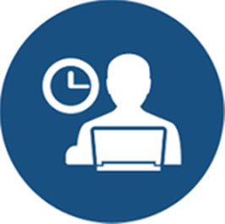
ATTENDANCE IS LIVE EVERY DAY!

Make sure that you click the link and enter your name and student ID EVERY SINGLE DAY THAT SCHOOL IS IN SESSION!

https://forms.gle/wJdmx91ffWHYQ64y7

If you do not fill out the form, you will be marked absent! It only takes a couple clicks!

New School Protocols
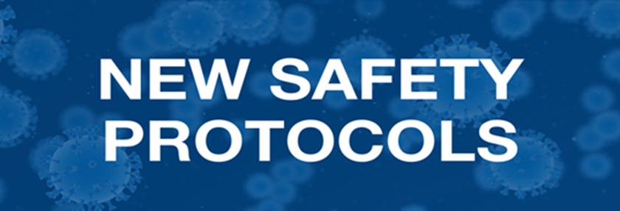
► Common Spaces will be used for instruction.
► Lunch is served in classrooms during instruction. No outside lunch
► Limited office and teacher hangout time (Moved online)
► Staircases A and C are Up, Staircases C-D are Down (Follow Decals)
► Elevators are only for use of faculty and students with medical approval.
► Distancing at the Swipe Station
► Masks are REQUIRED for the duration of the day. No Exceptions.
If you cannot comply, please select full time remote learning

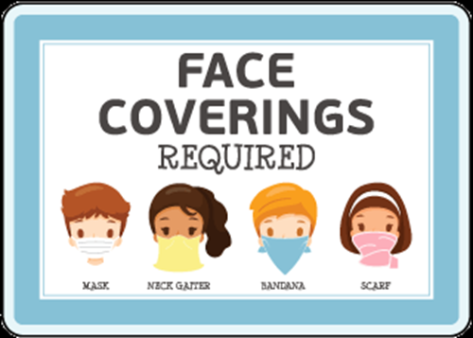

► Maximum of 9 - 11 students per class
► Tutoring, clubs, PM school, and events will all happen remotely so all students have equal access
► Students are required to bring laptops to school each day for instruction. Any student who needs a laptop will be assigned one.
► Stay 6 ft. apart

► Wash hands often with soap and warm water
► Cough in your Elbow
► Avoid touching your face
► If you are feeling sick, you MUST stay home!
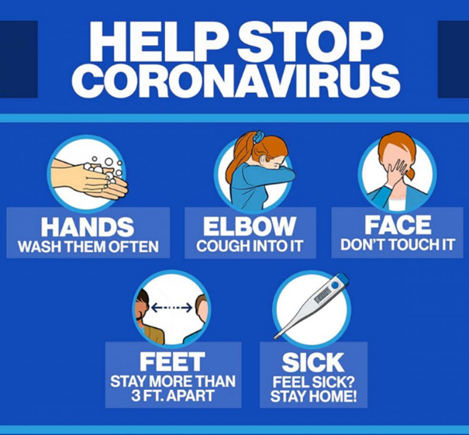
► No congregating in the lobby or outside the school at dismissal. Use all front exit doors as exits.
► Movement on all floors will be one directional! Floor decals will tell us which direction to travel and your teachers will remind you at the end of class! Keep it moving and stay on the right
Example: Mr. Lee (Room 1123) at the end of the lesson may remind students “Don’t forget, make a right out of the classroom! A/C is up and C/D is down!”

Blended/Remote Learning Platforms
Google Classroom will be the primary remote learning platform used as this is already part of the school’s culture. Teachers will be using their existing Google Classroom accounts to share all of our distance learning resources for all subject areas. Students are expected to login daily for access to their schoolwork and submit their work in Google Classroom. Some assignments will extend across days, others may be added weekly or daily. If a student is having trouble with logging in, they will be able to email Mr. Ahsan or Ms. Contreras for a password reset and/or support.
In order to support students remotely, Zoom accounts have been created for all teachers, guidance counselors, the college advisor, and administrators. Teachers will utilize Zoom Meetings to virtually create instructional videos to upload to Google Classroom and be available to students through meeting times on a daily basis. We will use Zoom for students to provide video conferencing as an additional support and check-ins to ensure students have everything they need. Students will be able to log onto a meeting and ask questions of their teachers on a daily basis. While Google Meets was previously used by most faculty, Zoom provides breakout room (small group instruction) opportunities that Google cannot provide.

Pupilpath is updated weekly by teachers. If you have any questions about your grade, email your teachers immediately so we can troubleshoot your issue!

Technology Support/Assistance
If you are in need of tech assistance, please email our tech supervisor, Mr. Contreras at JContreras@schools.nyc.gov
If you are in need of a laptop or a hotspot to be mailed to your house, contact your guidance counselor!
- Academic Concerns: 9th Grade - Ms. Cox acox@schools.nyc.gov
- Academic Concerns: 10th Grade – Mr. Reyes Nreyes@schools.nyc.gov
- Academic Concerns: 11th Grade - Ms. Montero mmontero@schools.nyc.gov
- Academic Concerns: 12th Grade – Ms. Pace Lpace@schools.nyc.gov
PM School

Will be completely online and published by Mid-September on the schools website! Stay tuned!

Tutoring Schedule
Will be completely online and published by Mid-September on the schools website! Stay tuned!

Clubs
Will be completely online and published by Mid-September on the schools website! Stay tuned!

College Office

ART AND DESIGN College Office
Connect with Ms. Doulis at PDoulis@artanddesignhs.org
The services provided by the College Office include the following:
- Group presentations and workshops covering various essential aspects of student self-assessments, career planning, college search, college admissions, and financial aid process
- Individual college counseling sessions and application reviews
- Evening workshops for parents on college admissions and financial aid processes in bilingual English, Chinese, and Spanish.
- College campus visits
- Arranging visits to ART AND DESIGN by college admissions officers from various colleges and universities.
- Referrals for free SAT Preparation courses

Food Pick-Up School Locations

MEAL LOCATIONS IN ALL FIVE BOROUGHS!
Three meals a day are available to all New York City residents. No questions asked!

Here is a link to the school food page where you can enter your zip code and find all the locations for your neighborhood.
www.opt-osfns.org/schoolfoodny/meals/default.aspx​​​​​​​

Let us know if you have any questions or concerns. If you need any assistance at all, first email hrodriguez19@schools.nyc.gov

Mental and Physical Health

No one is returning to Art and Design with the impression that this school year is in any way “normal”. There are a number of services that ART AND DESIGN provides both inside and outside of the classroom! We are here not just for our students but for your entire family! Please refer to the contact page and reach out to any staff member listed for assistance.

Additionally, we have renewed our partnership with the Association to Benefit Children (ABC), whose clinical support in social work and training for student groups and staff will be instrumental in making Art and Design a place of learning with the right mental health supports.

Mindfullness and Mental Health for You

CHILD-MIND INSTITUTE – COPING THROUGH COVID
https://childmind.org/
NASP: Helping Children Cope With Changes Resulting From COVID-19 (guidelines in English, Spanish, Chinese, Amharic, Korean, French, and Vietnamese)
Health and wellness apps offer free services to help those coping with coronavirus
Drawing Classes with Famous Illustrators (this one might be fun for you and the kids! Carson Ellis is one of our favorite illustrators and she has an amazing instagram thing going.)
Talking with Children: Tips for Caregivers, Parents, and Teachers During Infectious Disease Outbreaks: https://store.samhsa.gov/system/files/pep20-01-01-006_508_0.pdf
Stress and Coping: https://www.cdc.gov/coronavirus/2019-ncov/prepare/managing-stress-anxiety.html
Caring for Children in a Disaster: https://www.cdc.gov/childrenindisasters/helping-children-cope.html
(snippet from artherapy.org)

Resources for the Public
- If you need help, please text SHARE to 741741 to reach a crisis counselor with Crisis Text Line. You can also call The Lifeline at 1-800-273-8255 to be connected to free and confidential support and crisis resources for you or your loved ones.
- Check out the Quarantine Family Toolkit by Kristin Ramsey, ATR-BC, LPC, which offers suggestions and resources on how to talk with children about COVID-19, a sample daily schedule for working/learning at home, online apps, podcasts and other resources for daily activities, mindfulness activities and short guided muscle relaxation script, as well as many art activities instructions and examples.
- Resources for addressing COVID-19 — The National Council for Behavioral Health offers resources to help manage coronavirus-related anxiety and to communicate with your kids about this crisis among other topics. Behavioral health care workers will also find resources including telehealth best-practices and implications for certain vulnerable client groups.

Remote Learning Expectations
I want to reiterate before we begin, that we are here for you 100%. Whatever you need, please reach out for support! A few contact reminders before we begin…
- Technology Issues: Fahsan@schools.nyc.gov
- General Information or Concerns: Jjohnson32@schools.nyc.gov
- Academic Concerns: 9th Grade - Ms. Cox acox@schools.nyc.gov
- Academic Concerns: 10th Grade – Mr. Reyes Nreyes@schools.nyc.gov
- Academic Concerns: 11th Grade - Ms. Montero mmontero@schools.nyc.gov
- Academic Concerns: 12th Grade – Ms. Pace Lpace@schools.nyc.gov
- Discipline and Social Issues: Mr. McCalla, Assistant Principal bmccall2@schools.nyc.gov
- Assistant Principal of Math and Instructional Support – Ms. Budney tbudney@schools.nyc.gov
- Assistant Principal of English, Social Studies, World Language– Ms. Rosales lrosales@schools.nyc.gov
- Assistant Principal of Arts and CTE – Ms. Reingold Ereingo@schools.nyc.gov
- Assistant Principal of Guidance and Sciences – Ms. Daly Mdaly6@schools.nyc.gov
- Principal: Maximillian Re-Sugiura mresugiura@schools.nyc.gov
A few reminders before we begin regarding online learning and standards…

Since schools are shifting classroom learning online, we want to ensure that our students are able to engage safely and respectfully. More importantly, these guidelines are here to honor our mental health and wellness.

Please review the following document carefully as it outlines important guidelines and responsibilities expected of students, parents/guardians, and teachers.

Online Guidelines
In general, all students are expected to use good judgment and common sense; be safe, appropriate, careful and kind online.

Student Responsibilities
Students must:
- Follow all school and class rules for technology and the same guidelines for respectful, responsible behavior online that students are expected to follow offline.
- Collaborate in positive ways that help you learn.
- Use technology to support an inclusive school community.
- Be cautious to protect the safety of the student and others.
- Alert a teacher or other staff member if students see threatening, inappropriate, or harmful content (images, messages, posts) online.
- Email RespectForAll@schools.nyc.gov or call Respect for All at 212-374-2350 for support on keeping a respectful online community.
Students must not:
- Open emails from unknown senders. If the sender is not an Art and Design teacher or staff, do not open the email and do not respond. Flag any suspicious or inappropriate email as SPAM.
- Engage in cyberbullying, harassment, or disrespectful conduct toward others. Such conduct will result in disciplinary action and loss of privileges. In some cases, cyberbullying can be a crime. Teachers will refer this behavior to the Deans or AP of Security for follow-up with you and your family.
- Use a school account to send spam or chain mail.
- Use language online that would be unacceptable in the classroom.
Students are expected to demonstrate positive behaviors in alignment with the Department of Education’s Citywide Behaviors to Support Student Learning (see below).

Student Personal Safety and Privacy
- Users should never share personal information, including phone number, address, social security number, birthday, or financial information, over the Internet without adult permission.
- Users should recognize that communicating over the Internet brings anonymity and associated risks, and should carefully safeguard the personal information of themselves and others.
- Users should never agree to meet someone they meet online in real life without parental permission. If students see a message, comment, image, or anything else online that makes them concerned for their personal safety, they should bring it to the attention of an adult immediately.

Parent Responsibilities
- Make sure your child acts responsibly. This includes knowing and understanding the Discipline Code, Internet Acceptable Use and Safety Policy (IAUSP), and Social Media Guidelines for Students 12 and Younger or 13 and Older.
- Keep track of your children's online use when they are not in school—including mobile apps, online games, and other social media
- Share values with your children and talk with them about what is—and is not—acceptable online behavior.

Teacher Responsibilities
- Support students through regular communication via Google Classroom.
- Maintain healthy boundaries for students and faculty: The 8:52 AM to 2:16 PM school day still remains. Please do not engage in official email or electronic communication prior to 6am or after 9pm.
- Only share Google Classroom codes to students and families in your class
- Send invitations to Zoom meetings to students in your classes.
Please also see:
NYC DOE Digital Citizenship guidelines

The Citywide Behavioral Expectations to Support Student Learning Grades K-5
(A19, A21, A31, A32, A36, A37, A38)
The Citywide Behavioral Expectations to Support Student Learning Grades 6-12
(B19, B27, B30, B32, B34, B39, B40)
A-832 Student-to-Student Discrimination, Harassment, Intimidation and/or Bullying
https://www.schools.nyc.gov/docs/default-source/default-document-library/a-832-student-to-student-discrimination-harassment-intimidation-and-or-bullying​​​​​​​
Artists in Residence (AIR)

Every other Tuesday afternoon, grade level teams meet via zoom to discuss groups of students that need additional support. These groups are based on students who are not demonstrating mastery of skills that would allow them to meet graduation requirements as set forth by NYC DOE academic policy. Parents and students are welcomed to schedule an appointment to join the assigned Mentor-in-Residence or schedule a PEG meeting in order to devise a plan so we can better support your young professional in their learning. Mentors-in-Residence will reach out to their AIRs and families in order to create a relationship that will lead to success over the entire school year, See below for times and which guidance counselor to contact to schedule an appointment. We are here to support you!

Remote Department Meetings
Each day of the week, teachers meet in departments and discuss instructional strategies, remote learning assignments and student work products through remote learning. If you have any feedback you would like to provide the different departments, please contact a member of the Instructional Leadership Team below! We would love to hear from you regarding how we may be able to improve our students remote learning experience!
- Assistant Principal of Physical Education/ Health: Mr. McCalla, Assistant Principal bmccall2@schools.nyc.gov
- Assistant Principal of Math and Instructional Support – Ms. Budney tbudney@schools.nyc.gov
- Assistant Principal of English, Social Studies, World Language– Ms. Rosales lrosales@schools.nyc.gov
- Assistant Principal of Arts and CTE – Ms. Reingold Ereingo@schools.nyc.gov
- Assistant Principal of Guidance and Sciences – Ms. Daly Mdaly6@schools.nyc.gov
Blended/Remote Learning Resources

Update For Families on Fall Learning Options
Transitions for Families
The below provides an overview of how families can transition between blended and remote learning and guidance for schools on keeping track of updates and communicating with families. The DOE will revisit these policies and adjust on an as-needed basis.
The default is that students will participate in blended learning based on the scheduling model the school selects.
Families can opt into 100% remote learning at any time using the Learning Preference online form.
Families who choose 100% remote learning can opt back into blended learning on a quarterly basis during a set timeframe three weeks before the quarter begins. Schools will have two weeks before quarters begin to program students accordingly and communicate to families their blended learning schedule. Schools will have access to real-time reports indicating students who have opted into 100% remote learning.
Because families can opt into remote learning at any time, schools should review these reports on a daily basis. In these same reports, schools will be able to see which students who had previously opted into 100% remote learning are opting back into blended learning on a quarterly basis.

Timeline
Below is a possible timeline for when families will be able to opt back into blended learning on a quarterly basis.
July 15 – August 7 Families can begin opting into 100% remote learning
Week of August 10 DOE sends reports to schools indicating which students have opted into 100% Remote Learning
All other students should be programmed for blended learning (based on model school selects)
Week of August 24 Families informed of their fall schedules by their school
First Day of School – November 13 Quarter 1
October 26 – 30 Blended Learning Opt-In Window for Quarter 2
Week of November 2 Schools program students newly opted in to Blended Learning
Week of November 9 Schools inform students newly opted in to Blended Learning of their schedule
Monday, November 16 Quarter 2 Begins
November 16 – January 29 Quarter 2
January 11 – 15 Blended Learning Opt-In Window for Quarter 3
Week of January 18 Schools program students newly opted in to Blended Learning
Week of January 25 Schools inform students newly opted in to Blended Learning of their schedule

What are some existing resources (not already in wide circulation) that can be used to support students, families, and teachers?
- Spectrum free internet for students for 60 days: https://www.engadget.com/2020/03/16/spectrum-freeinternet-students-coronavirus/
- Resources for Parents during Coronavirus: https://docs.google.com/document/d/1I7sgng1PpoczZu9BJ8EJ0R8KcMPDTkR502omvJmUNT4/edit
- What to do with the kiddos: https://docs.google.com/document/d/1f3r3ASehz4LMG0Av0_yLmGvl3A7hCVGzP4K09TXOzM8/edit
- Homeschool Resources: https://docs.google.com/document/d/1rBqt7UJ7U_8Nz0mnLgbRd3TsSgzoJ1gawefZPCNNmAY/preview

Whole School Full Time Remote Schedule (If Needed)

In the event that the school returns to full time Remote Learning, we will maintain our current program as it is a modification of our Spring 2020 program.

COVID-19 Updates

Multisystem Inflammatory Syndrome in Children (MIS-C)

The DOE is committed to keeping families informed about recent developments regarding Multisystem Inflammatory Syndrome in Children (MIS-C). MIS-C is a new health condition associated with COVID-19 that is appearing in children in New York City and elsewhere. The syndrome was previously called Pediatric Multisystem Inflammatory Syndrome (PMIS). MIS-C is like other serious inflammatory conditions, such as Kawasaki disease and toxic shock syndrome. Since children with MIS-C may become seriously ill, it is important that families know the signs and symptoms their children may experience, so they can get help right away. Please refer to the letter at the bottom of the page for more information from the Chancellor.

Covid 19 Facts

Updates from the NYC DOE: https://www.schools.nyc.gov/school-life/health-and-wellness/coronavirus-update
Mayor Bill de Blasio and Schools Chancellor Richard A. Carranza announced the City will move towards a new Remote Learning Model for all school days until Spring Recess.
- Students will not report to school buildings for instruction during this time.
- Learn at Home for grades K-12 has all you need to know for getting set up for remote learning.
- Regional Enrichment Centers are available for the children of first responders, healthcare workers, transit workers, and other essential workers.
- Grab-and-Go free meals are available at the entrance of select buildings.
- School buildings are scheduled to reopen to students following Spring Recess on Monday, April 20, 2020.
- Text COVID to 692-692 to receive regular SMS texts with the latest news and developments
- See the new COVID-19: FAQ for Parents and Caregivers of Pre-School and School-Age Children

